UNITED STATES

SECURITIES AND EXCHANGE COMMISSION

Washington, D.C. 20549

FORM 8-K

CURRENT REPORT

Pursuant to Section 13 or 15(d) of the Securities Exchange Act of 1934

Date of report (date of earliest event reported): April 13, 2026

iPower Inc.

(Exact name of registrant as specified in its charter)

Nevada | 001-40391 |  |  |  |  | 82-5144171
(State or other jurisdiction |  |  | (Commission File Number) |  |  | (IRS Employer
of incorporation) |  |  |  |  |  | Identification No.)
 |  |  | 8798 9th Street
 |  |  | Rancho Cucamonga, CA 91730
 |  | (Address of Principal Executive Offices) (Zip Code)
 | (626) 863-7344
 |  | (Registrant’s Telephone Number, Including Area Code)
 | ___________________________
 | (Former name or former address, if changed since last report.)

Check the appropriate box below if the Form 8-K filing is intended to simultaneously satisfy the filing obligation of the registrant under any of the following provisions:

- Written communications pursuant to Rule 425 under the Securities Act (17 CFR 230.425)

- Soliciting material pursuant to Rule 14a-12 under the Exchange Act (17 CFR 240.14a-12)

- Pre-commencement communications pursuant to Rule 14d-2(b) under the Exchange Act (17 CFR 240.14d-2(b))

- Pre-commencement communications pursuant to Rule 13e-4(c) under the Exchange Act (17 CFR 240.13e-4(c)) Securities registered pursuant to Section 12(b) of the Act:

Title of each class |  | Trading Symbol(s) |  | Name of each exchange on which registered
Common Stock $0.001 per share |  | IPW |  | The Nasdaq Stock Market LLC

Indicate by check mark whether the registrant is an emerging growth company as defined in Rule 405 of the Securities Act of 1933 (§230.405 of this chapter) or Rule 12b-2 of the Securities Exchange Act of 1934 (§240.12b-2 of this chapter).

Emerging growth company ☒

If an emerging growth company, indicate by check mark if the registrant has elected not to use the extended transition period for complying with any new or revised financial accounting standards provided pursuant to Section 13(a) of the Exchange Act. ☐

Item 1.01. Entry into a Material Definitive Agreement.

Sublease

On April 13, 2026, iPower Inc, a Nevada corporation (“iPower” or the “Company”), finalized a sublease agreement (the “Sublease Agreement”) with Dezheng Logistics Inc., a California corporation (“Dezheng”), pursuant to which the Company subleased its warehouse, located at 8798 9th Street, Rancho Cucamonga, California, 91730 (the “Premises”), to Dezheng for a fixed term of 25 months, commencing May 1, 2026 and ending May 31, 2028.

Pursuant to the Sublease Agreement, Dezheng provided a security deposit to the Company of $338,130 and thereafter will pay Base Rent (as such term is defined and calculated in the Sublease) to the Company monthly. In exchange, Dezheng will have the right to use and occupy the Premises to conduct its business as a third-party logistics company.

The existing lease agreement governing the Premises between the Company, as tenant, and 9th & Vineyard LP, a Delaware limited partnership (“9th & Vineyard”), as successor in interest to the landlord, dated July 28, 2021 (including all amendments thereto, the “Master Lease”) required the Company to seek 9th & Vineyard’s consent prior to entering into the Sublease Agreement. As such, the Company, Dezheng, and 9th & Vineyard entered into a second amendment and consent to the Master Lease (the “Second Amendment”), pursuant to which 9th & Vineyard consented to the Sublease. In

exchange for such consent, 9th & Vineyard required a letter of credit and an additional security deposit, which was paid for by Dezheng on April 13, 2026, at which time the Sublease Agreement became effective. The Sublease Agreement remains subject and subordinate to the Master Lease, which was filed as Exhibit 10.1 to the Current Report on Form 8-K filed August 2, 2021.

The foregoing summary of the Sublease Agreement does not purport to be complete and is qualified in its entirety by reference to such agreement, the form of which is filed with this Current Report on Form 8-K as Exhibit 10.1 and is incorporated herein by reference.

Item 5.07. Submission of Matters to a Vote of Security Holders.

On April 13, 2026, the Company held its 2026 annual meeting of stockholders (the “Annual Meeting”), at which the Company’s stockholders considered three proposals, each of which is described in more detail in the Company’s definitive proxy statement filed with the Securities and Exchange Commission on March 4, 2026. At the Annual Meeting, there were a total of 1,293,177 votes eligible to be cast and a total of 793,391 shares voted in person or by proxy, representing 61.35% of the total number of votes eligible to be cast. The final voting results for each matter are set forth in more detail below.

- Election of Directors.

All of the following five nominees were elected to the Company’s board of directors, in accordance with the voting results listed below, to serve for a term of one year, until the next annual meeting and until their successors have been duly elected and have qualified.

Nominee |  | For |  | Against |  | Withheld |  | Broker Non-Votes
Chenlong Tan |  | 570,017 |  | 0 |  | 1,137 |  | 222,237
Yue Guo |  | 570,025 |  | 0 |  | 1,129 |  | 222,237
Bennet Tchaikovsky |  | 569,393 |  | 0 |  | 1,761 |  | 222,237
Yi Yang |  | 569,870 |  | 0 |  | 1,284 |  | 222,237
Hanxi Li |  | 569,996 |  | 0 |  | 1,158 |  | 222,237

2

- Ratification of the Company’s Independent Auditors.

Stockholders ratified the appointment of HTL International LLP as the Company’s independent auditors for the fiscal year ending June 30, 2026, in accordance with the voting results below.

For |  | Against |  | Abstain
792,254 |  | 1,019 |  | 118

- Approval of the Company’s Executive Compensation.

Stockholders approved (on an advisory basis) the Company’s executive compensation.

For |  | Against |  | Abstain |  | Broker Non-Votes
568,503 |  | 2,263 |  | 388 |  | 222,237

Item 8.01. Other Events.

On April 14, 2026, the Company published a press release announcing the Sublease Agreement. The Company’s press release is furnished herewith as Exhibit 99.1.

The information provided in this Item 8.01 (including Exhibit 99.1 hereto), is being furnished and shall not be deemed “filed” for purposes of Section 18 of the Exchange Act, or otherwise subject to the liabilities of that section, nor shall it be deemed incorporated by reference into any filing under the Exchange Act or the Securities Act, except as expressly set forth by specific reference in such a filing.

Item 9.01. |  | Financial Statement and Exhibits.
(d) Exhibits.
Exhibit No. |  |  | Description
10.1 |  |  | Sublease Agreement, dated April 2, 2026, between iPower Inc. and Dezheng Logistics Inc.
99.1 |  |  | Press Release dated April 17, 2026

- Cover Page Interactive Data File (embedded within the Inline XBRL document).

3

SIGNATURES

Pursuant to the requirements of the Securities Exchange Act of 1934, the registrant has duly caused this report to be signed on its behalf by the undersigned hereunto duly authorized.

IPOWER, INC.

Dated: April 17, 2026

By: /s/ Chenlong Tan
Name: Chenlong Tan

Title: Chief Executive Officer

4

Exhibit 10.1
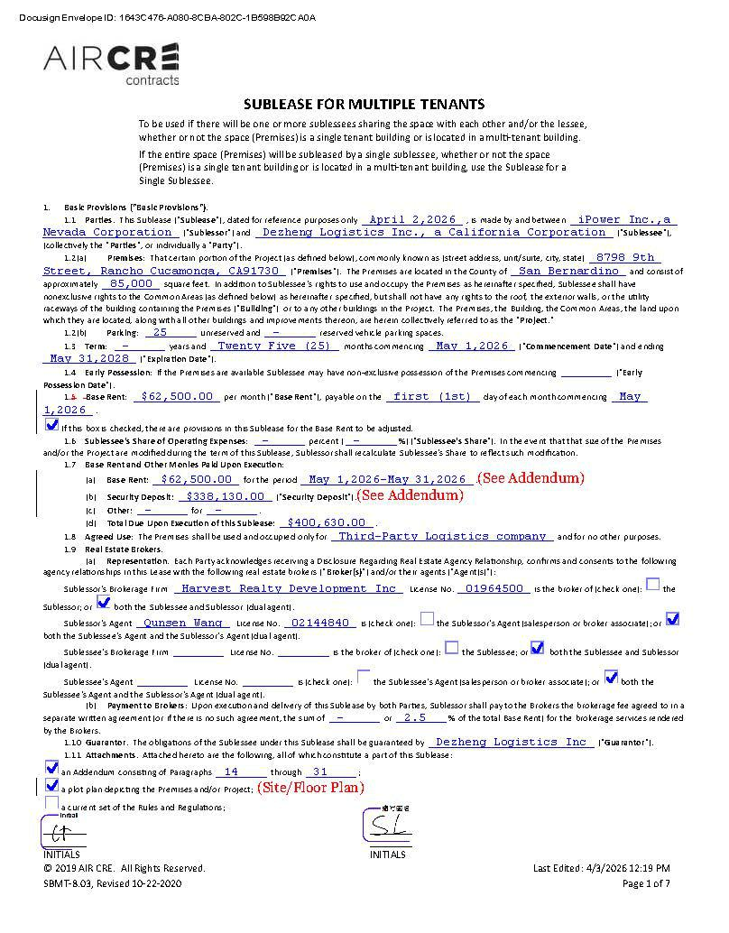

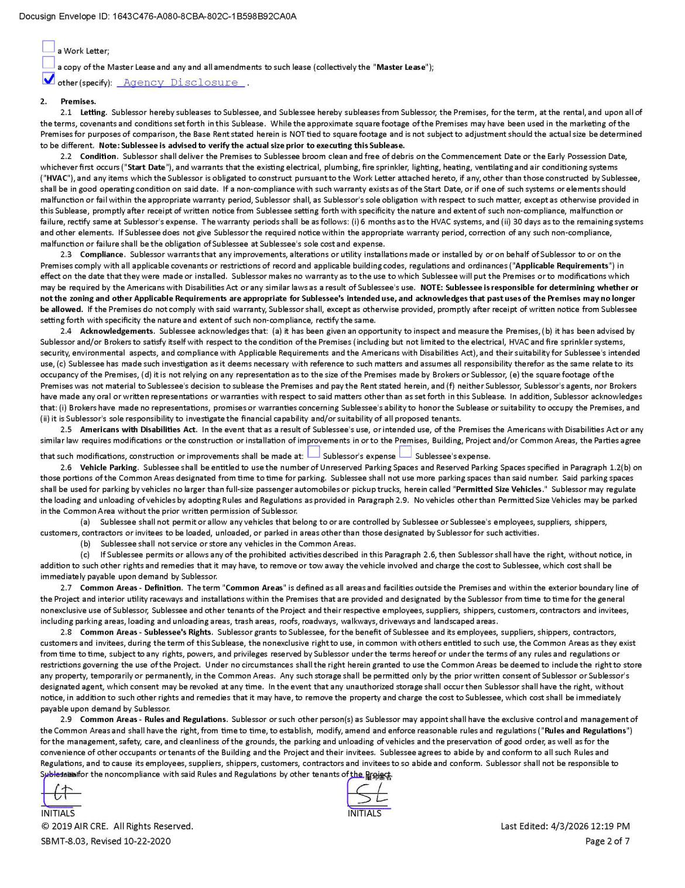

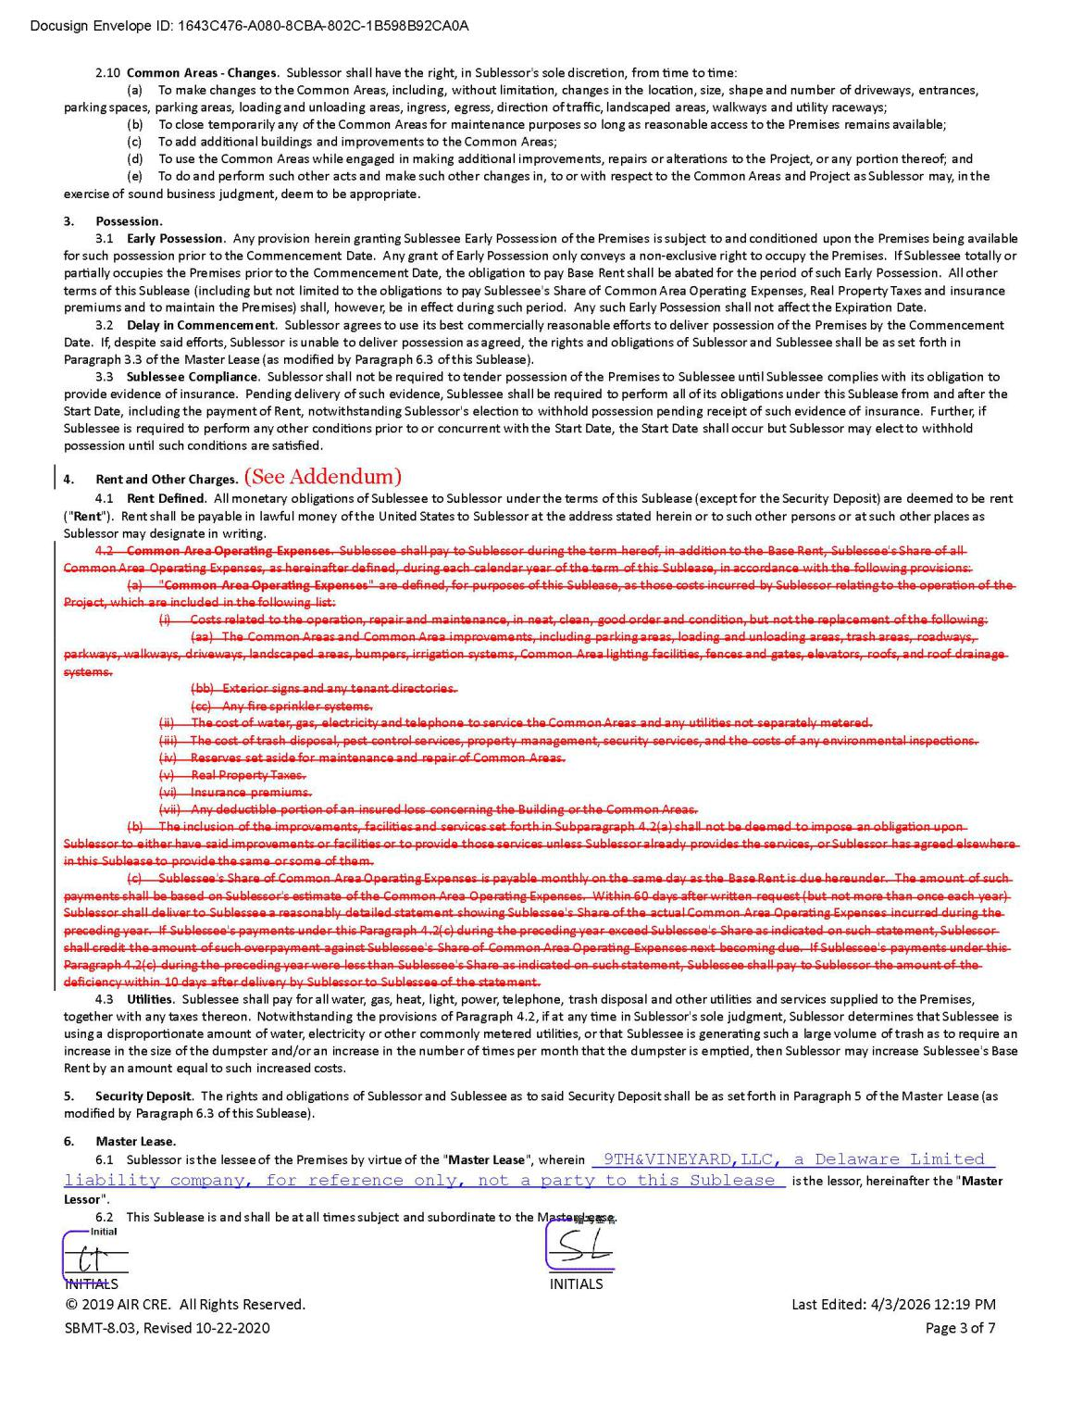

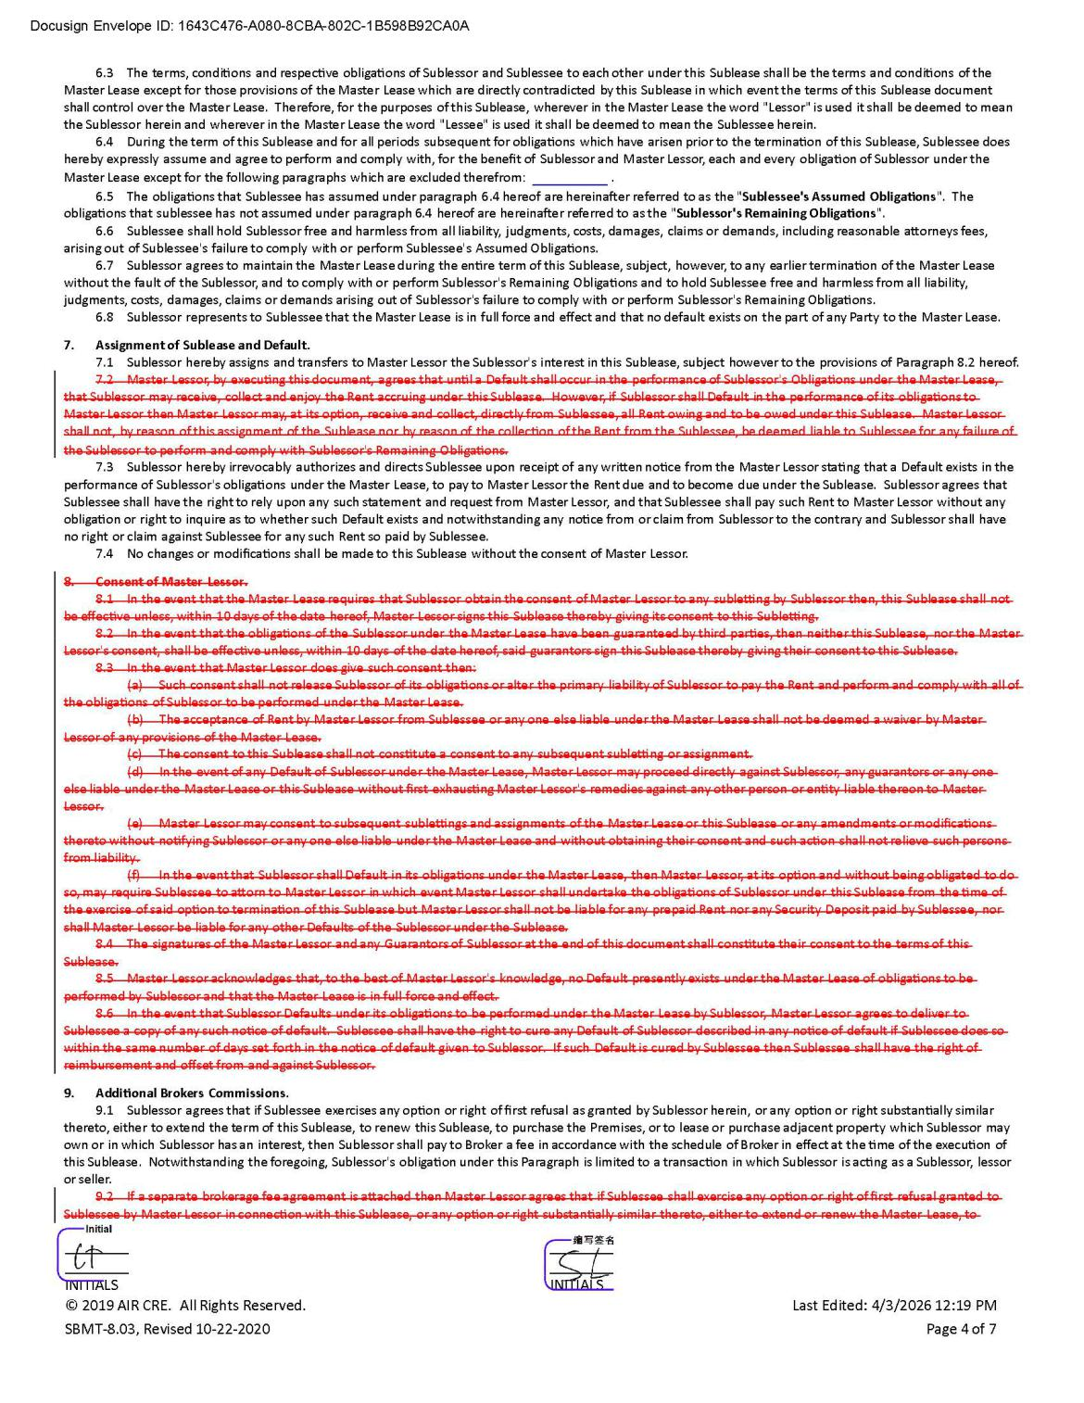

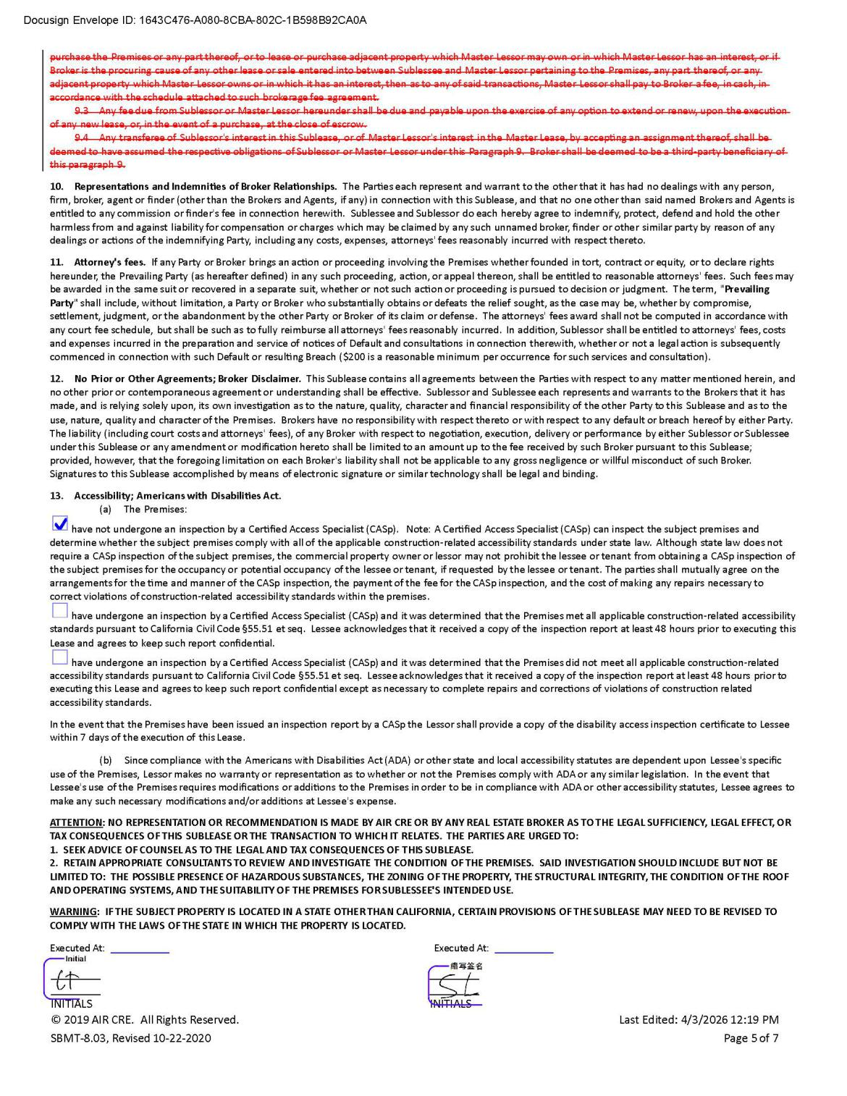

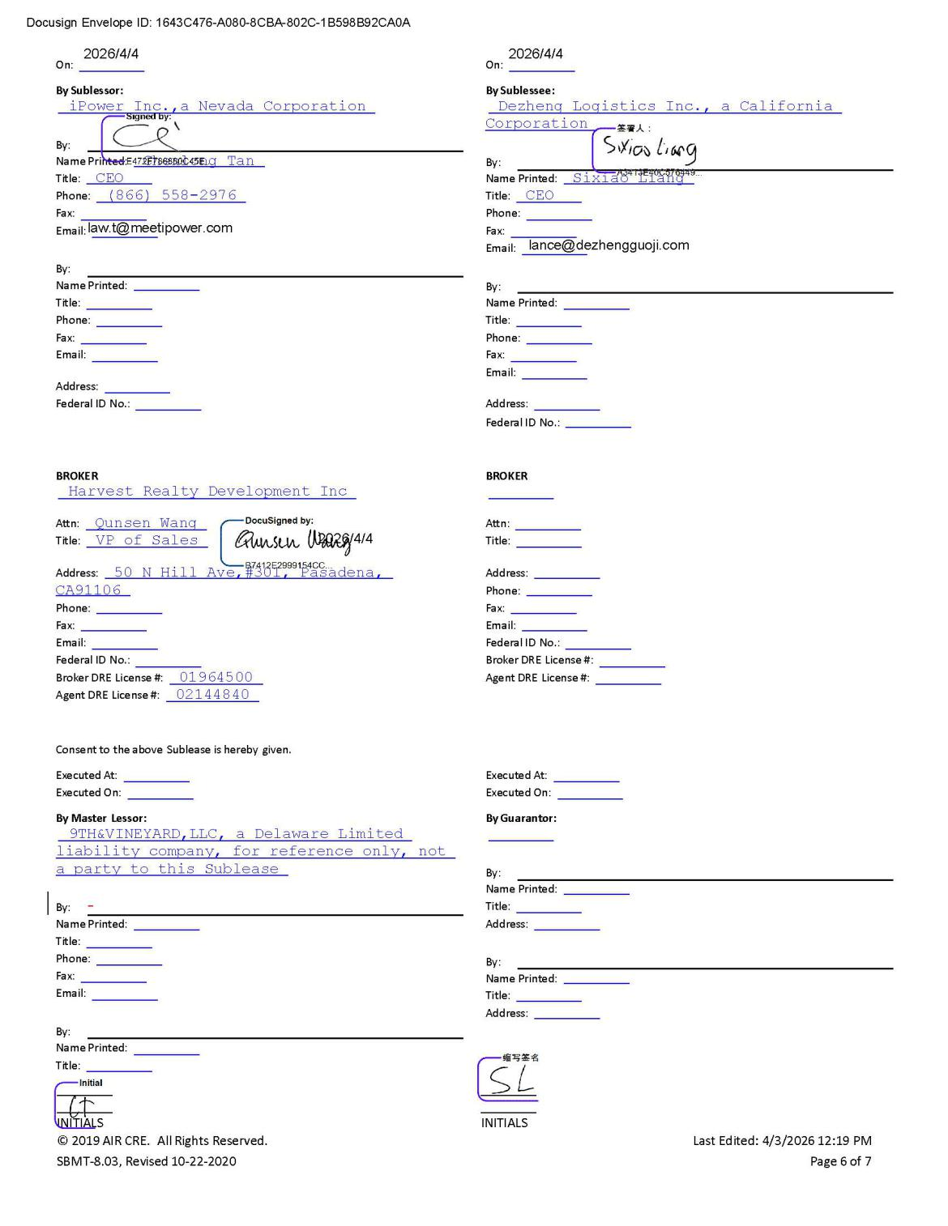

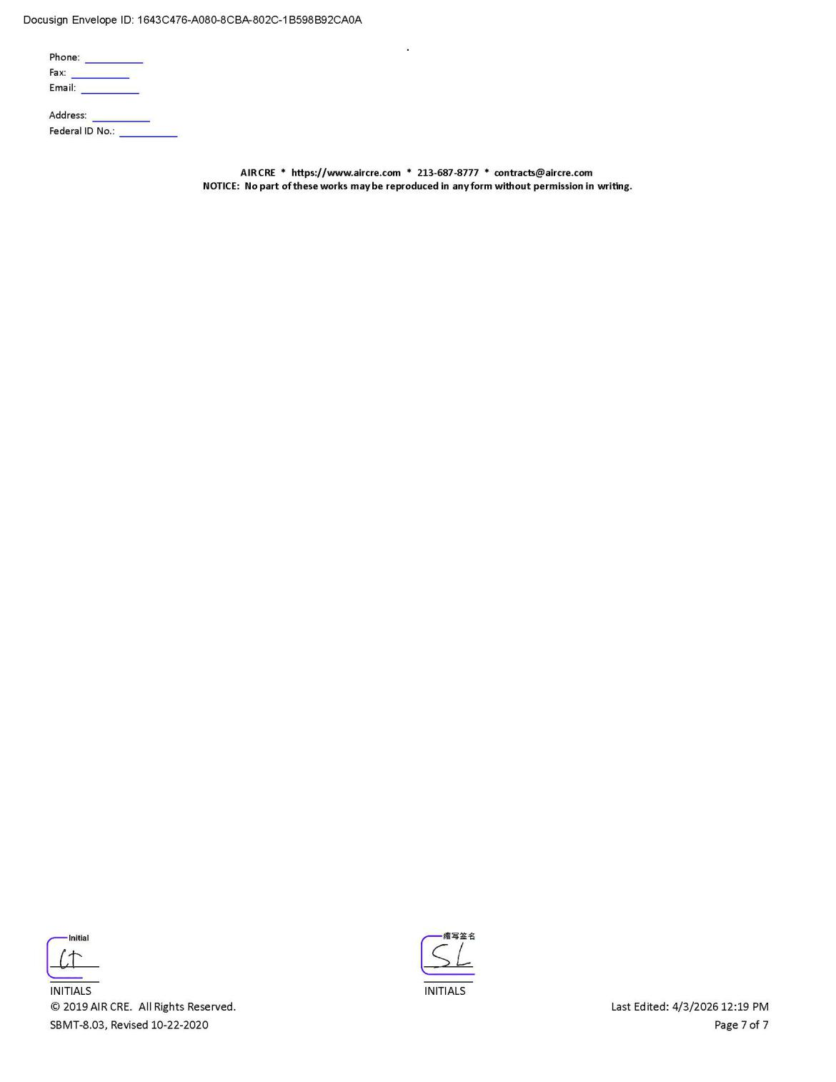

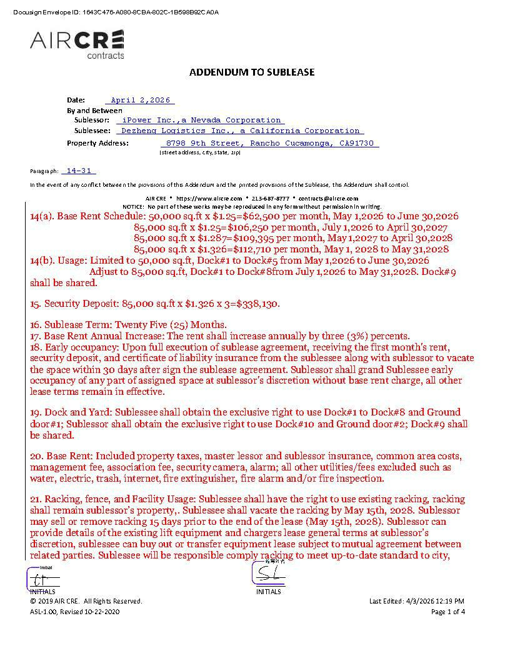

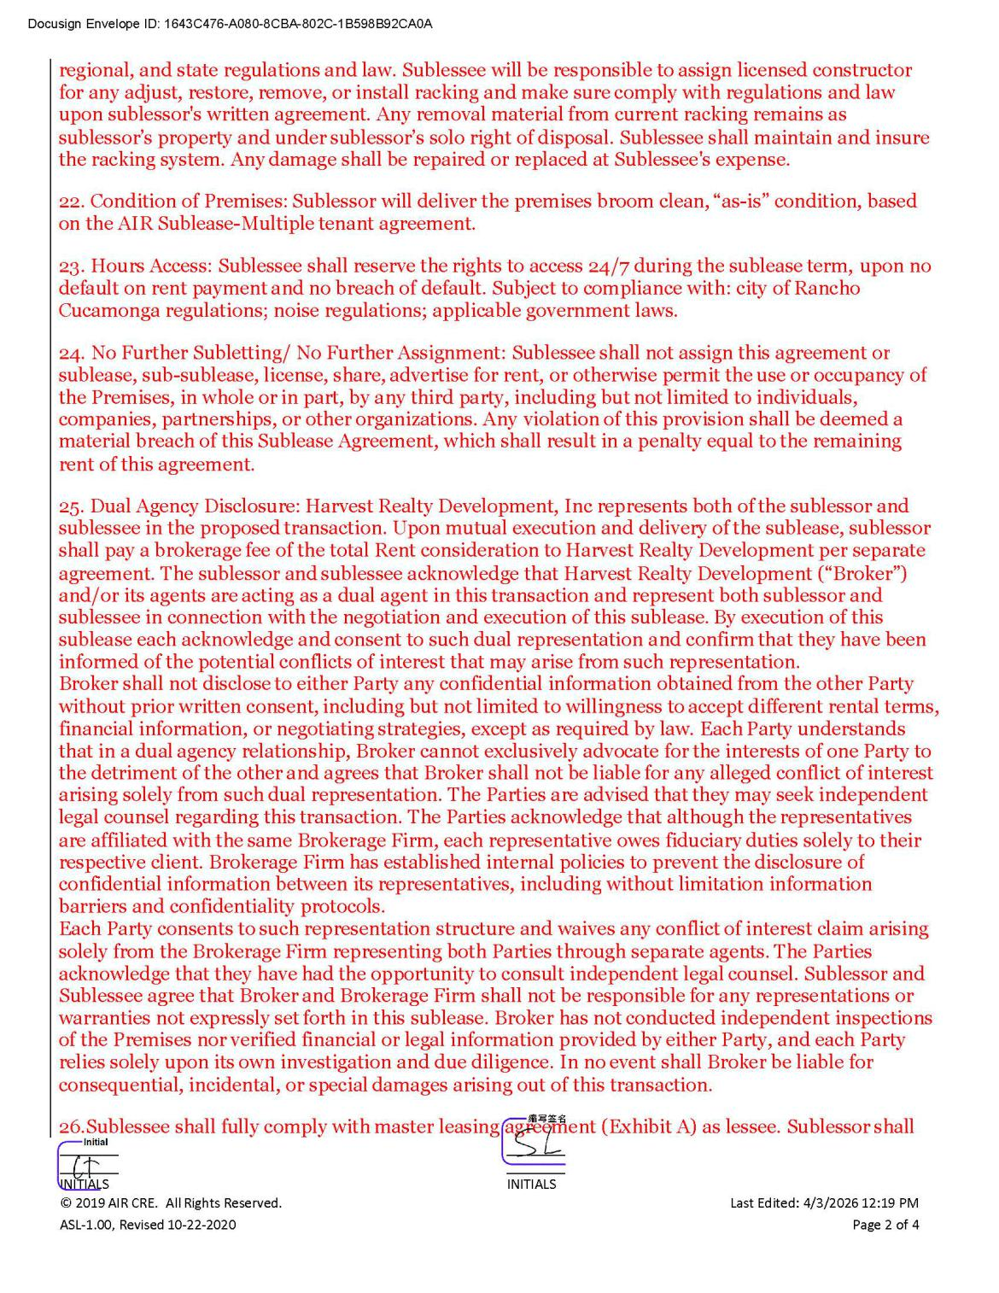

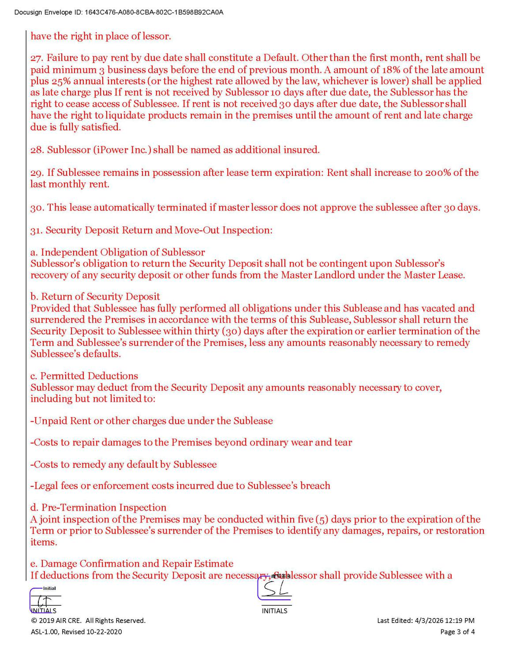

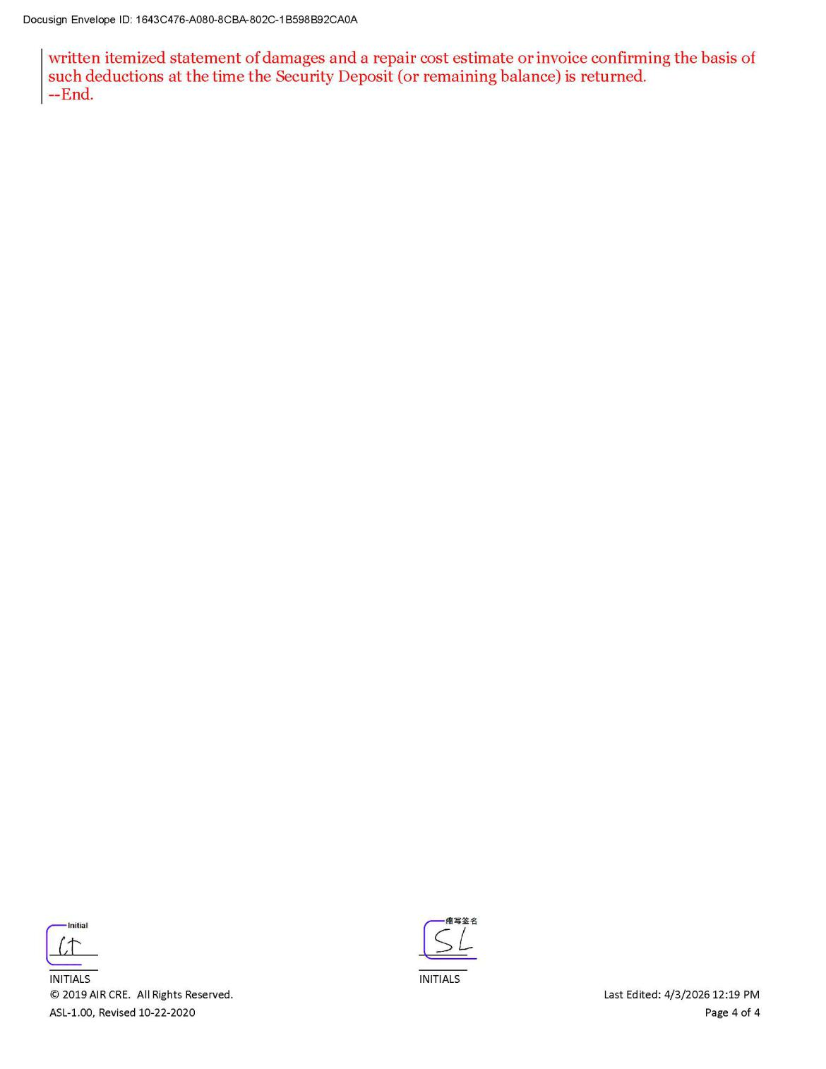

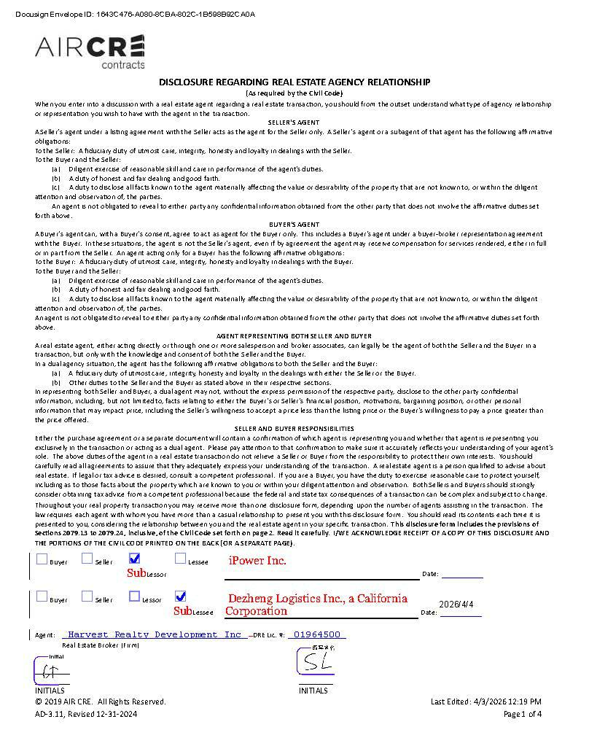

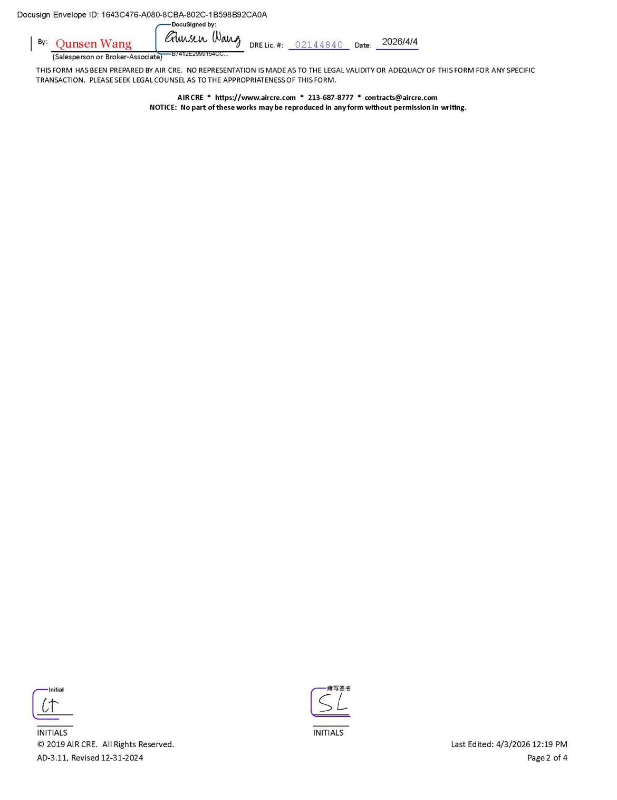

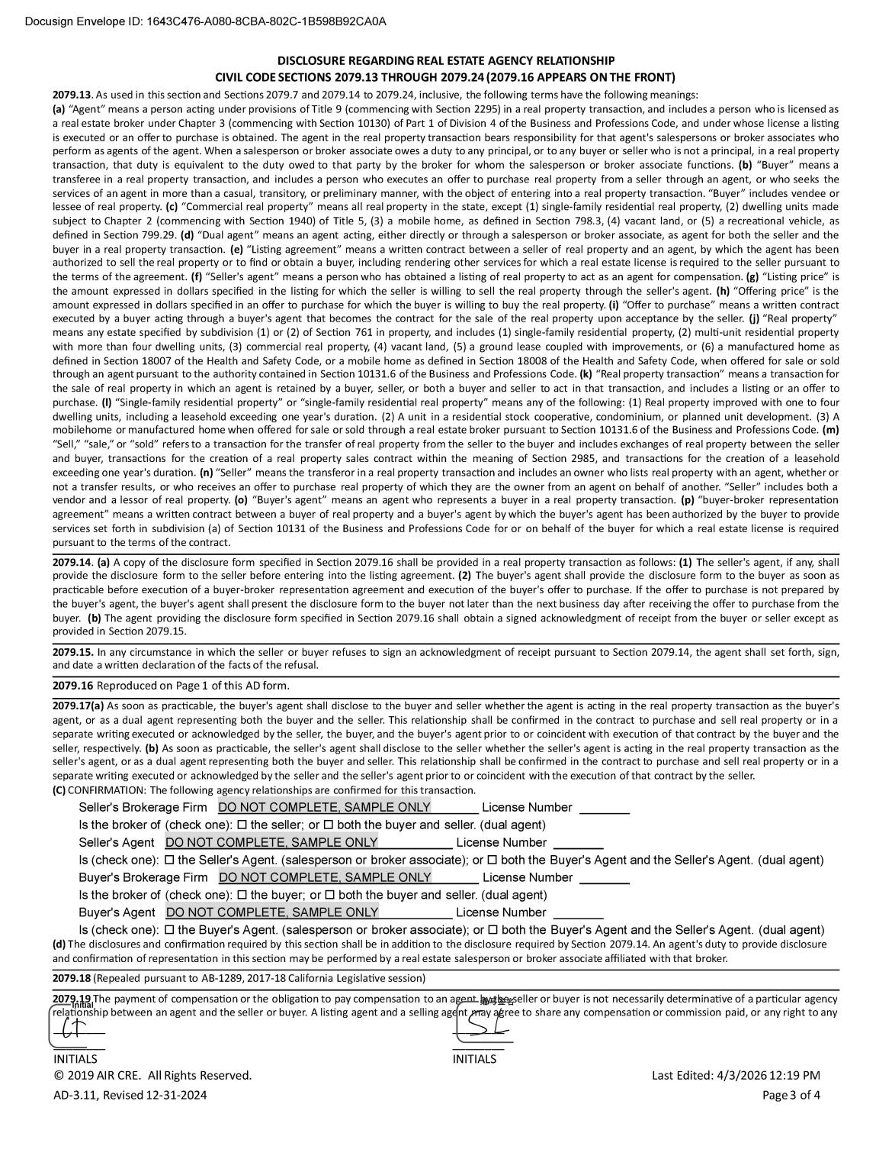

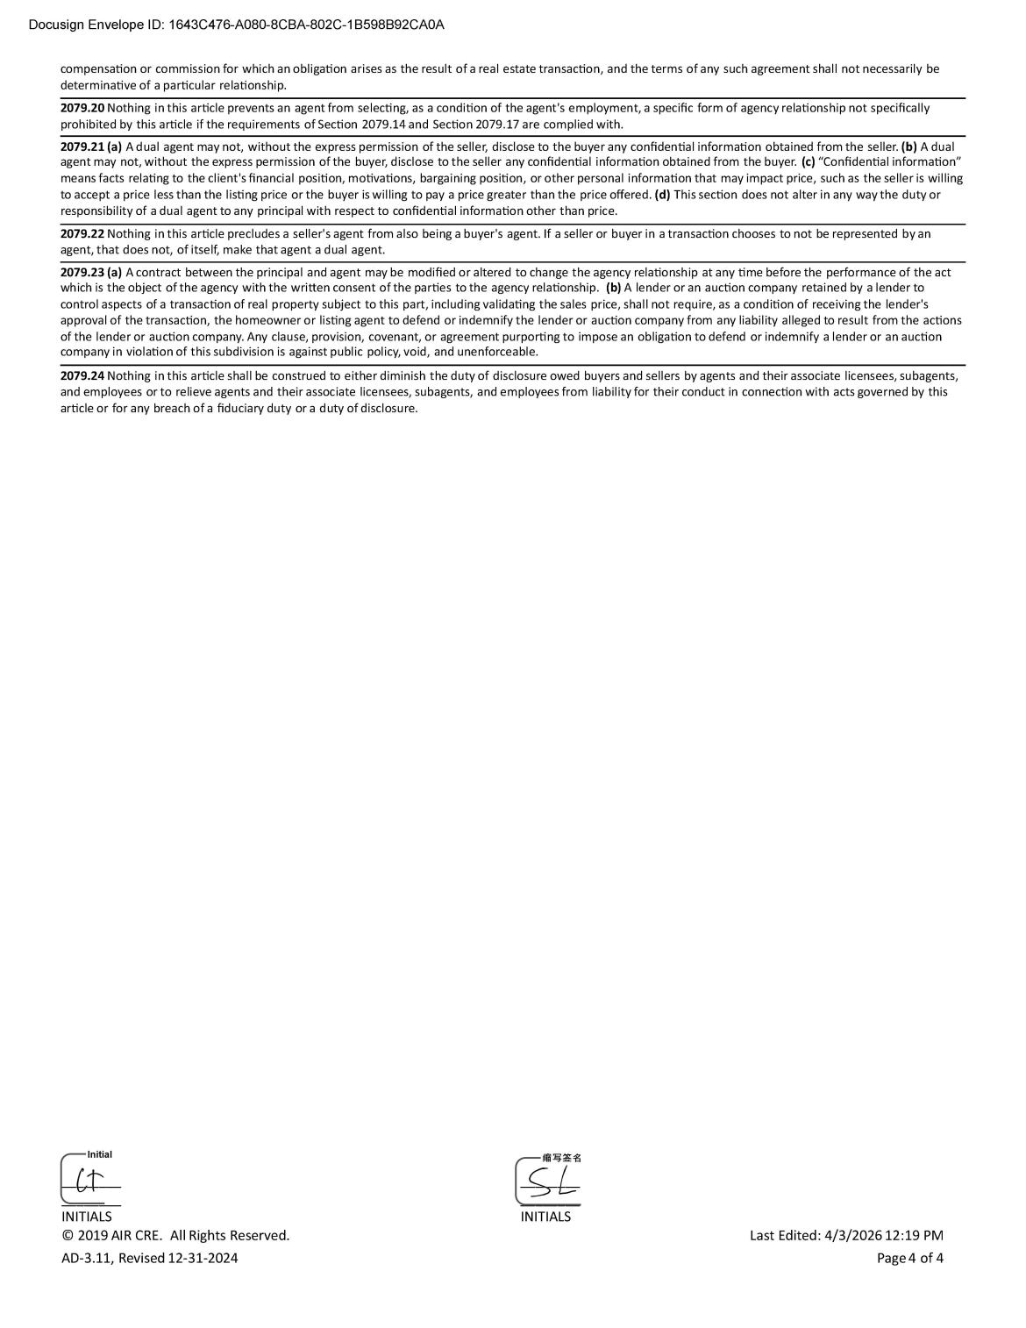

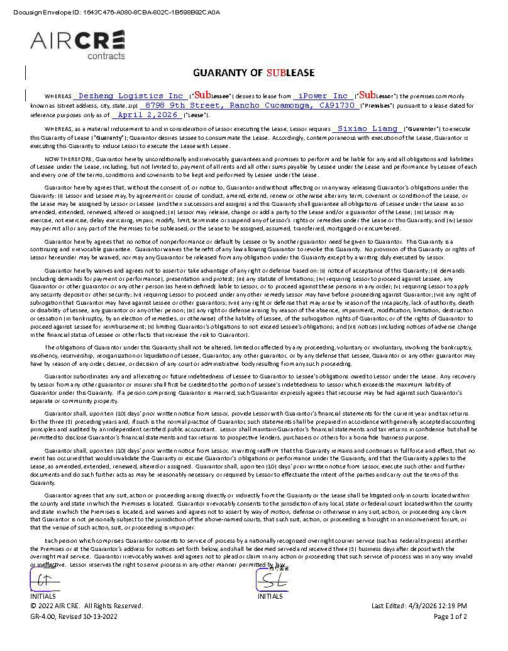

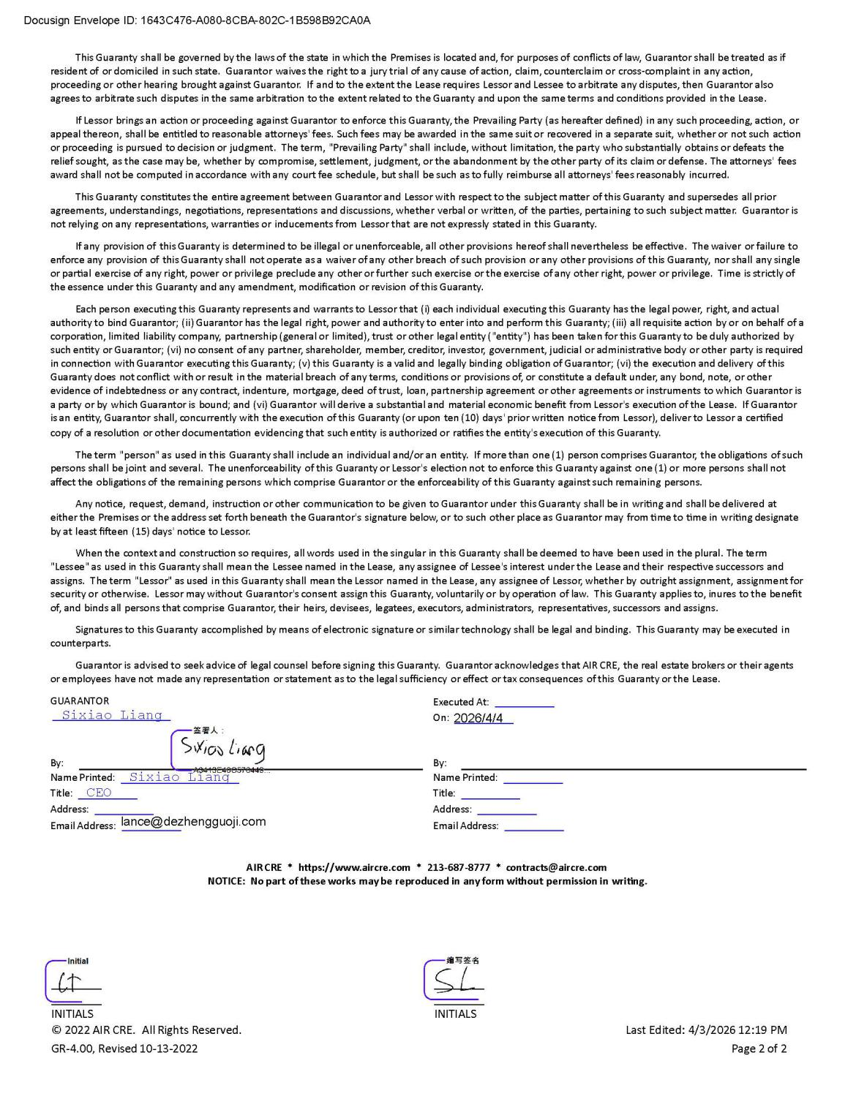

Exhibit 99.1


iPower Adds Over $2.6 Million in Contracted, Non-Dilutive Income Through Sublease Agreement

Agreement reinforces asset-light strategy and establishes recurring rental income stream from existing infrastructure

RANCHO CUCAMONGA, California, April 17, 2026 -- iPower Inc. (Nasdaq: IPW) (“iPower” or the “Company”) today announced that it has entered into a sublease agreement for a portion of its Rancho Cucamonga, California facility, creating a new stream of contracted, non-dilutive income over a 25-month term.

Under the agreement, the Company will generate base rental income beginning at approximately $62,500 per month, increasing to over $106,000 per month within the first three months and reaching approximately $112,700 per month by the final stage of the lease. In aggregate, the sublease represents over $2.6 million in contracted, non-dilutive income through May 2028.

The subleased premises comprise approximately 85,000 square feet and will be occupied by a third-party logistics operator. The sublease term commenced on May 1, 2026 and extends through May 31, 2028. Landlord consent for the sublease has been fully obtained.

“This transaction reflects our continued shift toward a more asset-light operating model,” said Lawrence Tan, Chief Executive Officer of iPower. “By converting underutilized space into a contracted income stream that scales to over $100,000 per month, we are enhancing capital efficiency while advancing our path toward sustainable profitability.”

The Company believes the sublease strengthens cash flow visibility, reduces a fixed cost burden, and demonstrates the Company’s ability to actively monetize existing infrastructure without any incremental capital investment.

About iPower Inc.

iPower Inc. (Nasdaq: IPW) is a technology- and data-driven supply chain and infrastructure provider for online retailers and brands, operating at the intersection of digital assets and real-world commerce. The Company delivers procurement, fulfillment, logistics, and software-enabled services, and is executing a broader crypto strategy through licensed partners and compliant infrastructure. For more information, please visit www.meetipower.com.

Forward-Looking Statements

All statements other than statements of historical fact in this press release are forward-looking statements. Such statements involve known and unknown risks and uncertainties and are based on current expectations and projections. Actual results may differ materially from those set forth herein. iPower undertakes no obligation to update forward-looking statements except as required by law. Investors are encouraged to review iPower’s filings with the Securities and Exchange Commission, including its Annual Report on Form 10-K, Quarterly Reports on Form 10-Q, and Current Reports on Form 8-K.

Media & Investor Contact

IPW.IR@meetipower.com

